Cognos Training – Level II
Basic Report Writing in Financial Data Mart (FDM) - List Reports

Cognos-DEV – https://cognos-dev.udel.edu/cognos8
Cognos (production) - https://cognos.udel.edu/cognos8

- Login with your UDelNet ID and password
- Under My Actions, choose Create professional reports (Report Studio)

Navigate to the yellow content folder FDM packages, click on name

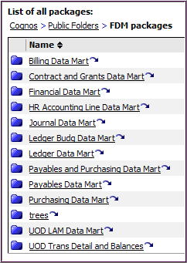
Click on Financial Data Mart package (blue folder)

This will launch Report Studio

Click Create a new report or template

Double-click the List icon
There are five main areas in the Report Studio tool:
Standard Toolbar

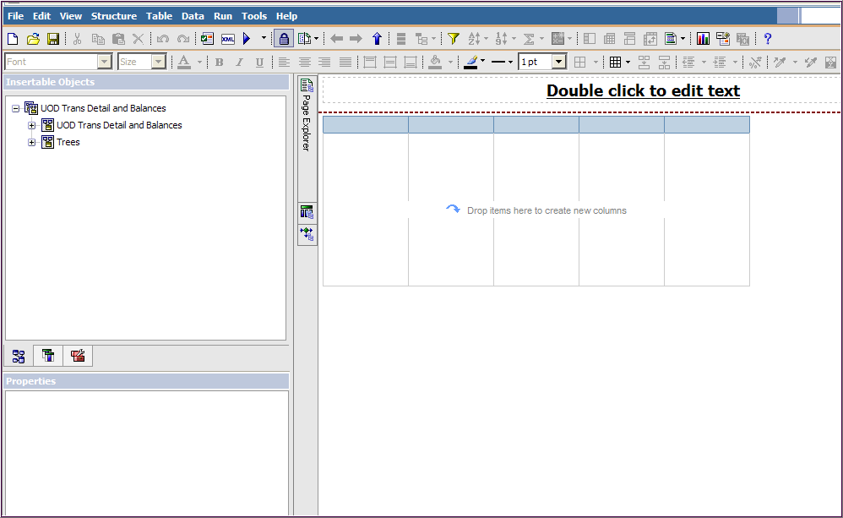
Insertable Objects pane:

(default)
Source Data Items Toolbox
Explorer Bar

Properties pane

- Page Explorer (default)
- Query Explorer
- Condition Explorer
Style Toolbar

Work Area
A. Create Basic Transaction Report

- Add the following 24 fields from UD Financial Data Mart/Financial Data Mart package to the Work Area:

Field Name | Query Subject | Folder
PURPOSE | Chart of Accounts | Purpose
PURPOSE DESCR | Chart of Accounts | Purpose
FISCAL_YEAR | Trans Detail | Dates
ACCOUNTING_PERIOD | Trans Detail | Dates
DEPTID | Chart of Accounts | Department
ACCOUNT | Chart of Accounts | Account
ACCOUNT_DESCR | Chart of Accounts | Account
ACCOUNT_TYPE | Chart of Accounts | Account
ACCOUNTING_DT | Trans Detail
TRANSACTION_DATE | Trans Detail
CLASS_FLD | Chart of Accounts | Class
FUND_CODE | Chart of Accounts | Fund
PROGRAM_CODE | Chart of Accounts | Program
CHARTFIELD_2 [Source] | Chart of Accounts | Chartfield2
CHARTFIELD_3 [UD UserField] | Chart of Accounts | Chartfield3
PROJECT_ID | Chart of Accounts | Project
LEDGER | Trans Detail | Ledger
TRANS_DESCRIPTION | Trans Detail
TRANS_SOURCE | Trans Detail
JOURNAL_ID | Trans Detail
VNDR_NAME1 | Trans Detail
VOUCHER_ID1 | Trans Detail | Voucher
JRNL_LN_REF | Trans Detail
TRANS_AMOUNT | Trans Detail

- Add 2 pre-written prompts to your report
(Hint- scroll to the bottom of the Insertable Objects):
- Double-click Purpose
- Double-click Between year and period

- Add Filter to only include ACTUALS Ledger and to exclude Statistics codes ENU and ENP
- Click anywhere in your report
- Click in the Tool Bar

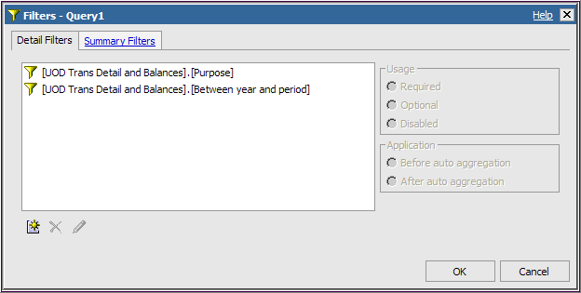
Note the two pre-written prompts created Filters

Click Add icon

- Filter for Ledger (a field in the report):
4. Verify the expression is valid by clicking the Validate button

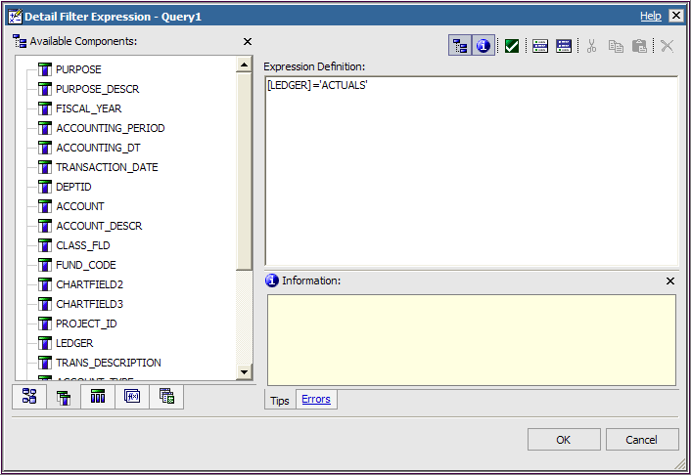
1. Click Data Items

5. Click OK once you get No Errors

No errors.
2. Double-click LEDGER to add it to the Expression Definition
3. Complete the expression by typing =’ACTUALS’

- Filter for Statistics Code (a field NOT in your report):
4. Click the Validate button

(fill-in the prompts)

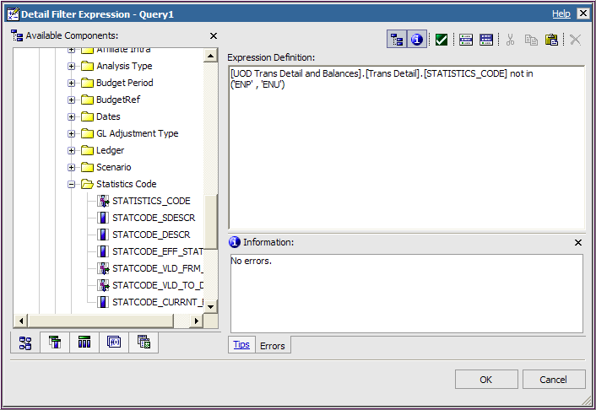
1. Stay on Source tab

5. Click OK once you get No Errors

2. Open Trans Detail
Open Statistics Code
Double-click on STATISTICS_CODE

3. Complete the expression by typing not in (‘ENP’ , ‘ENU’)

- Filter out transactions without a Journal ID:
4. Verify the expression is valid by clicking the Validate button

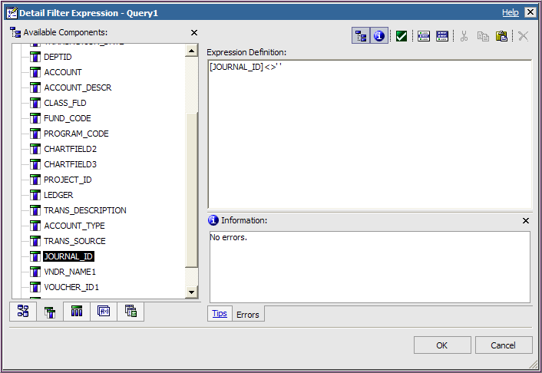
5. Click OK once you get No Errors

1. Click Data Items tab

2. Double-click JOURNAL_ID to add it to the Expression Definition
3. Complete the expression by typing <>’ ’

(There is a space between the single quotes; the expression means Journal ID not equal to blank.)
- Click Save and choose My Folders, name it BASIC List - Trans Detail

- Run the report, by clicking

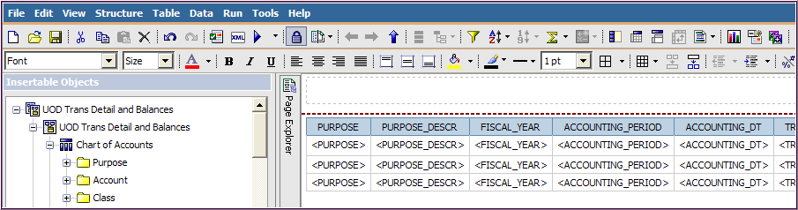

- Prompt page will appear with your previous values, click OK

- Cognos Viewer will appear with the results

- Navigate with scroll bars and links at the bottom

- Close the window

- Click Save

B. Modify the Transaction Report
Now we’ll make modifications to the report from the Work Area using the Toolbars:
12
5
7
3
2
6
1

13

- Save the report with a new name
  - Click File, select Save As, select My Folders
  - Change name to BASIC Trans Detail - mod1

- Remove fields
  - Click on column headings and then Delete
  - Suggestions – DEPTID, FUND_CODE, CHARTFIELD2, ACCOUNT_TYPE
  - Don’t delete LEDGER – it will mess-up the filter you created

- Sort by Fiscal Year, then Period and then Account
  - Click the FISCAL_YEAR heading and click Sort
  - Select Sort Ascending
  - Repeat for ACCOUNTING_PERIOD and ACCOUNT

- Change column order
  - Move JRNL_LN_REF to the right of JOURNAL_ID
  - Click & hold the JRNL_LN_REF heading, drag it to the left
  - Drop it when you see the thin black line next to JOURNAL_ID

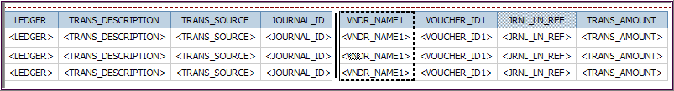

- Group by Purpose
Hint: this button is also used to Ungroup a field.

  - Click on PURPOSE heading
  - Click Group

- Save your work and run the report

- Add totals and subtotals to Transaction Amount
  - Click on TRANS_AMOUNT heading
  - Click Aggregate
  - Select Total
  - This will create a subtotal for each Purpose and a total at the bottom

- Group by Purpose Description, Fiscal Year and Period
  - CTRL-Click on these headings: PURPOSE_DESCR and FISCAL_YEAR and ACCOUNTING-PERIOD
  - Click Group

- Add Row Numbers as the first column
  - In the Insertable Objects pane, click Toolbox
  - Scroll down to Row Number
  - Click it and drag in front of PURPOSE, drop it when you see the thin black line

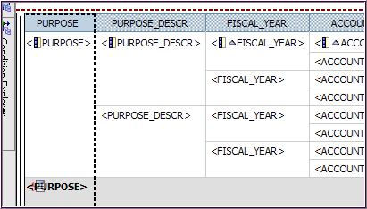

- Make Transaction Amount two decimal places
  - Click TRANS_AMOUNT column (it looks like <TRANS_AMOUNT>)
  - Go to the Properties pane (lower left)
  - In the Data section, click Data Format
  - Click the Ellipses to open the Data Format window
  - In Format type dropdown, select Number
  - In Properties, click No. of Decimal Places
  - Using dropdown, select 2
  - Click OK

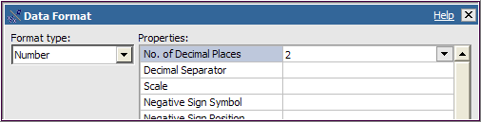

- Change Accounting and Transactions Dates to mm/dd/yyyy format
  - Click ACCOUNTING_DT column (it looks like <ACCOUNTING_DT>)
  - Go to the Properties pane (lower left)
  - In the Data section, click Data Format
  - Click the Ellipses to open the Data Format window
  - In Format type dropdown, select Date
  - In Properties, click Date Style and select Short
  - In Properties, click Display Years and select Show Century
  - Click OK
  - Repeat the process for TRANSACTION_DATE
  - Save your work

- Add a calculation for Percentage of Accounting Period Total
  - CTRL-Click on ACCOUNT and ACCOUNT_DESCR headings and click Group
  - Click TRANS_AMOUNT heading, click Aggregate , and select Total
  - This will create many totals that are not needed
  - Scroll to the left until your Work Area look like below
  - Delete these five (shown below), by highlighting the grey section and clicking :

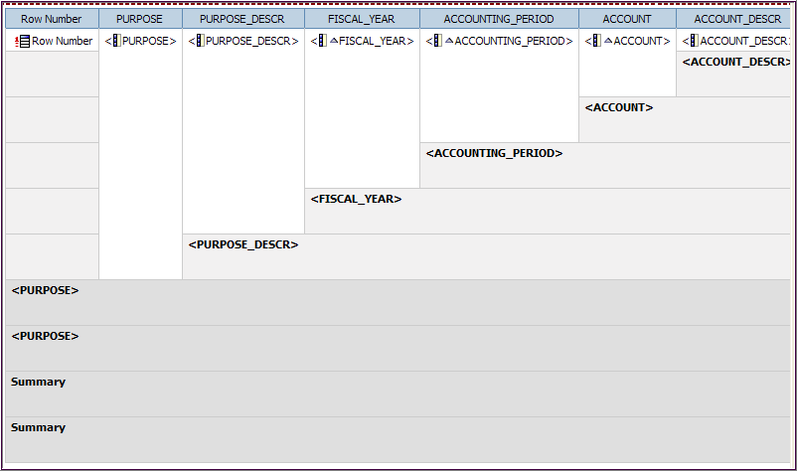
HINT – if you accidentally delete the wrong one, use Undo button.

[delete]
[delete – duplicate]
[delete – duplicate]
[delete]
[delete]
  - In the Insertable Objects pane, click Toolbox
  - Double-click Query Calculation
  - In the Create Calculation Name box, type: % of Period Total
  - Click OK, this opens the Data Item Expression window
  - In the Expression Definition:
  - Type - percentage(
  - Click Data Items tab, double-click TRANS_AMOUNT
  - Type - [space] for [space]
  - Double-click PURPOSE, FISCAL_YEAR and ACCOUNTING_PERIOD, putting a comma between them
  - Type - )

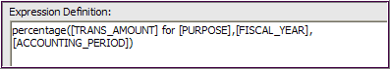

  - Validate the expression
  - When you see “No errors.”, click OK

- Create title
  - At the top of the page, double click the words Double click to edit text
  - In the Text box, type: Transactions
  - Change the format of the title by highlighting the text and using the Style Toolbar just as you would in Word
    - Change the color, font, italicize, etc.
    - Highlight the entire title area and click Left

- Create dynamic title by adding Purpose, Fiscal Year and Period (from prompt choices)
  - In the Insertable Objects pane, click Toolbox
  - Click Block and drag to title area, release when black dotted line surrounds the title area
  - Again click Block and drag to title area under the title area
  - Click Layout Calculation and drag it into the middle block
  - In the Report Expression window, click the Parameters tab
  - Double-click Select Purpose and click OK
  - Click Layout Calculation and drag it into the bottom block
  - In the Report Expression window, click the Parameters tab
  - Double-click from fiscal year and period and click OK
  - In the Toolbox, click Text Item and drag it next to <%ParamDisplay…%> in the bottom block
  - In the Text window, type: [space] [space] thru [space] [space]
  - Click Layout Calculation and drag it into the bottom block next to thru
  - In the Report Expression window, click the Parameters tab
  - Double-click to fiscal year and period and click OK
  - Run the report and then close Cognos Viewer
  - Save you work

- Add text to Footer
  - In the Insertable Objects pane, click Toolbox
  - Click Block and drag to footer area, release when black dotted line surrounds the footer area
  - Click Text Item and drag it into the new box
  - In the Text window, type: Created by [your name] and click OK
  - Save your work

- Download to Excel
  - Make sure your computer is setup properly to download to Excel (see instructions below)
  - Run the report and then close Cognos Viewer
  - In Cognos Viewer, click the View in button (upper right)
  - Click
  - Click or
  - Click Open
  - When saving, rename the file to something meaningful
Downloading to Excel

Make these three setting changes in Internet Explorer (7.0 or higher)
If your preferred browser is Firefox, you only need to do #3

- Tools/Internet Options/Security tab
  - Click Trusted Sites/Sites button,
  - Type https://cognos-dev.udel.edu in the top box and click Add
  - Click checkbox labeled Require server verification…
  - Click Close button

- Tools/Internet Options/Security tab
  - In the section called Security level for this zone, click Custom level… button
  - Scroll to Downloads
  - Automatic prompting for file downloads – click Enable
  - File download – click Enable
  - Are you sure you want to change the setting for this zone? Click Yes
  - Click OK button

- Tools/Pop-up Blocker/Pop-up Blocker Settings
  - Type cognos-dev.udel.edu in the top box and click Add
- Click checkbox - Play a sound when pop-up is blocked
- Click checkbox - Show Information Bar when pop-up is blocked
  - Click Close button

- Create a new Prompt for Account
  - From My Folders, Open the report, BASIC List - Trans Detail

  - Save it with new name (File/Save As) – BASIC List w new Prompt

  - Click anywhere in the report’s work area

  - Click Filter

  - Click Add
  - In Available Components, click the Data Items tab

  - Double-click ACCOUNT to add it to the Expression Definition

  - Type: =?Account? (Your expression should look like below.)

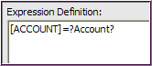

  - Validate the expressions and click OK after you see “No errors.”

  - Save your work

  - Run the report

Note – In Step h. above, you could create this expression instead, where the prompt would allow multiple Account values:

[ACCOUNT] in ?Account?

